Name

Mathematics Stage 5 Core
Coordinate Geometry

Book 1 | Find the midpoint, gradient, and distance between two points on the Cartesian plane | Version: 260720  Feedback:  https://MrDingMaths.com
Contents
Syllabus Content 2
Gradient 3
Gradient from Coordinates 7
Midpoint 13
Distance 17

Syllabus Content
MA4-LIN-C-01 determines the midpoint, gradient and length of an interval, and graphs linear relationships, with and without digital tools
Find the midpoint and gradient of a line segment (interval) on the Cartesian plane
- Plot and join 2 points to form an interval on the Cartesian plane and use the interval as the hypotenuse of a right-angled triangle
- Apply the relationship gradient $m=\frac{rise}{run}$ to find the gradient/slope of the interval joining the 2 points
- Distinguish between intervals with positive and negative gradients from a diagram
- Explain why horizontal intervals have a gradient of 0 and vertical intervals have undefined gradients using the gradient relationship
- Determine the midpoint of horizontal and vertical intervals on the Cartesian plane
- Apply the process for calculating the mean to find the midpoint, $M$ of the interval joining 2 points on the Cartesian plane
- Use graphing applications to find the midpoint and gradient/slope of an interval
Find the distance between 2 points located on the Cartesian plane
- Use the interval between 2 points as the hypotenuse of a right-angled triangle on the Cartesian plane and apply Pythagoras’ theorem to determine the length of the interval joining the 2 points
- Use graphing applications to find the distance between 2 points on the Cartesian plane

Gradient

- Gradient
The gradient measures a line’s steepness.
- Gradient: https://www.geogebra.org/m/jjqsdqxr
Positive Gradient  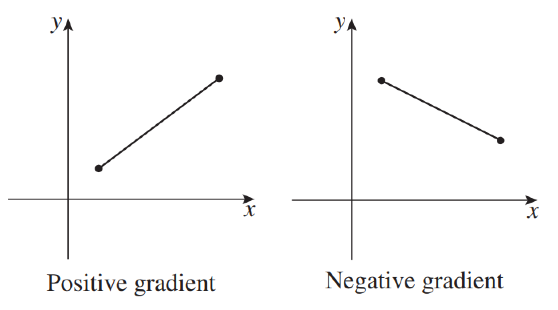  Line slopes up from left to right. | Negative Gradient  Line slopes down from left to right.

- Identify positive and negative gradients
Positive | Negative | Positive | Negative | Positive | Negative
Positive | Negative | Positive | Negative | Positive | Negative
Positive | Negative | Positive | Negative | Positive | Negative

- Key Ideas
- Gradient is ……………… if the line moves upwards from left to right, and negative if it moves downwards from ………… to …………

- Gradient Formula
Gradient, $m$, is the ratio of rise to run.
Gradient shows how far up or down for each unit to the right.
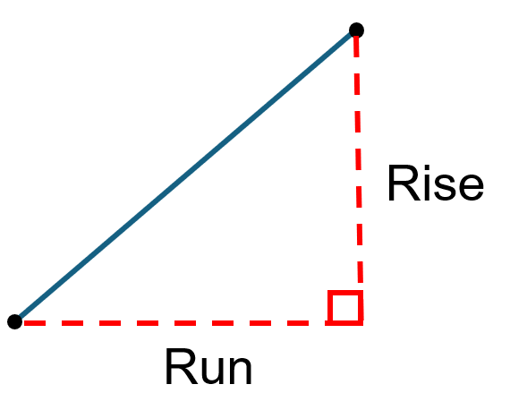
$$m=\frac{rise}{run}$$

To calculate gradient:
- Find the rise: vertical change between two points, from left to right.
  - Positive if line slopes upwards from left to right.
  - Negative if line slopes downwards from left to right.
- Find the run: horizontal change between two points, moving from left to right.
- Calculate gradient $m=$ $\frac{rise}{run}$.
- Simplify the fraction, if you can.

- Calculate gradient of an interval
Rise: ……  Run: ……  $$m=\frac{rise}{run}$$  $=$ | 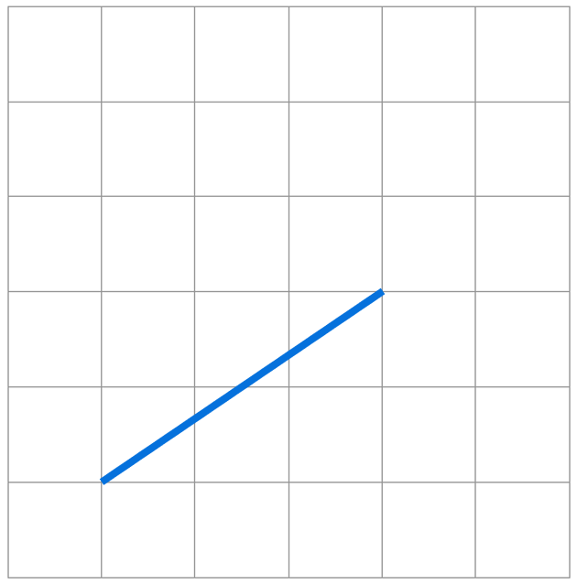  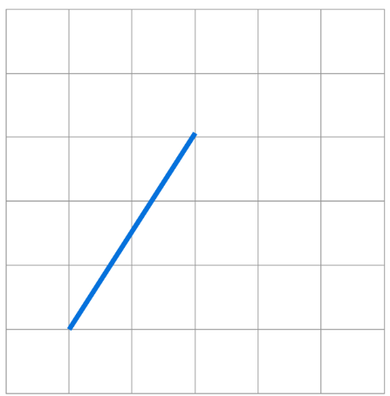  Rise: ……  Run: ……  $$m=\frac{rise}{run}$$  $=$ | 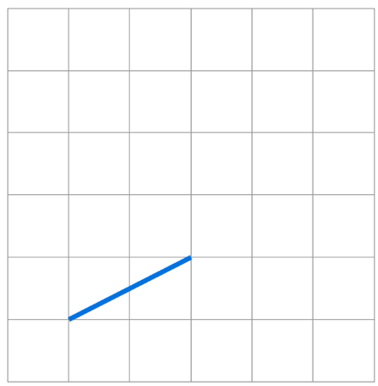  Rise: ……  Run: ……  $$m=\frac{rise}{run}$$  $=$
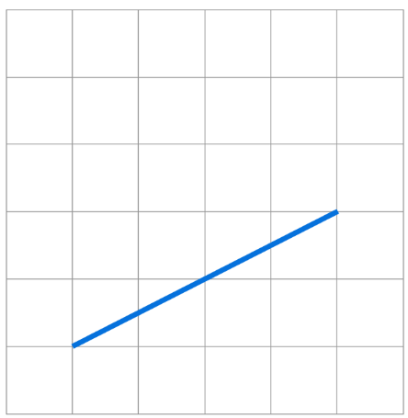 | 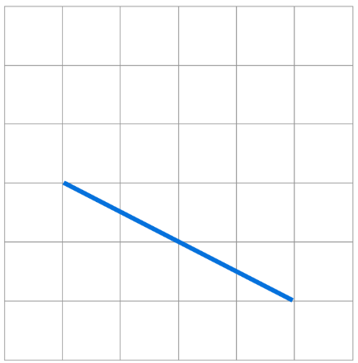 | 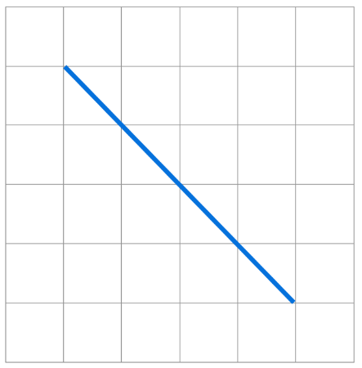
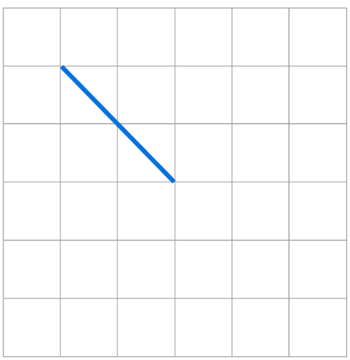 | 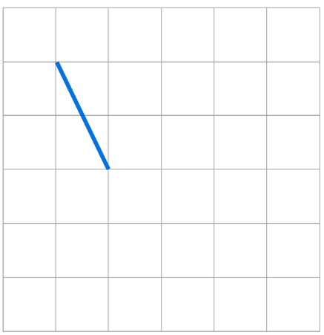 | 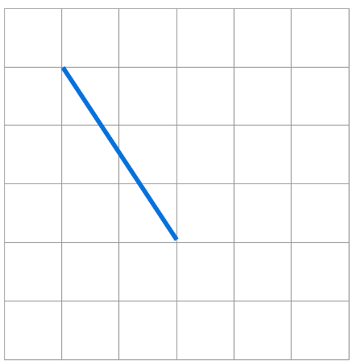

- Key Ideas
- Gradient is a r………… that describes the …………………… of a line.
- The gradient is a number that represents how much a line moves ………………… for every 1 unit to the right.

Foundation
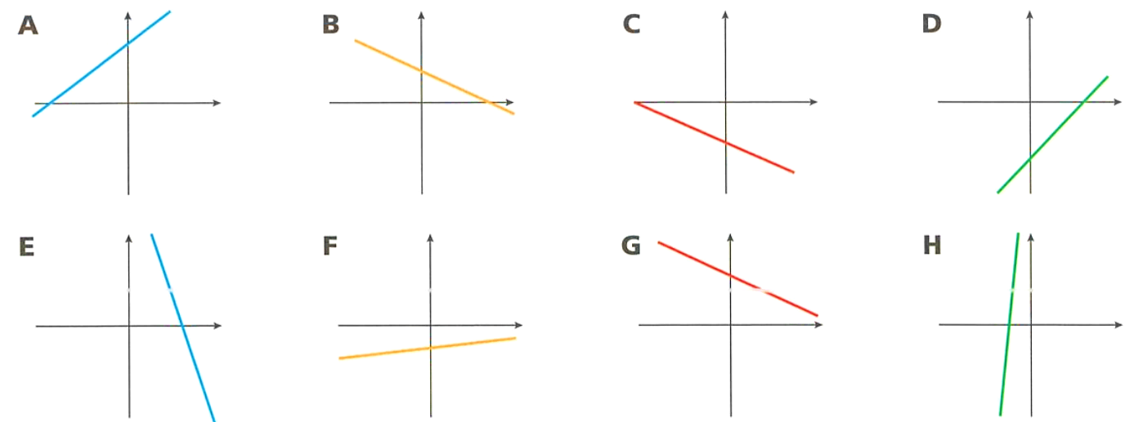
- Consider these lines. Circle the graphs with a negative gradient.

B, C, E, G

- Determine the gradient of the interval AB  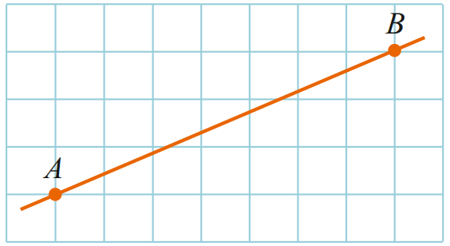  Rise: ………  Run: ………  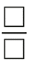  $$m=\frac{rise}{run}=$$  $$\frac{3}{7}$$ | 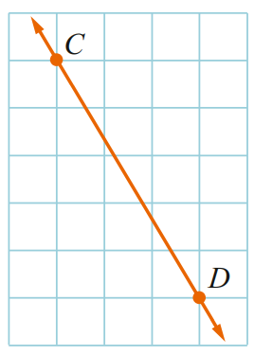  - Determine the gradient of the interval CD  Rise: ………  Run: ………  $$m=\frac{rise}{run}=$$  $$-\frac{5}{3}$$

- Determine whether the gradient is positive or negative and then find the gradient.
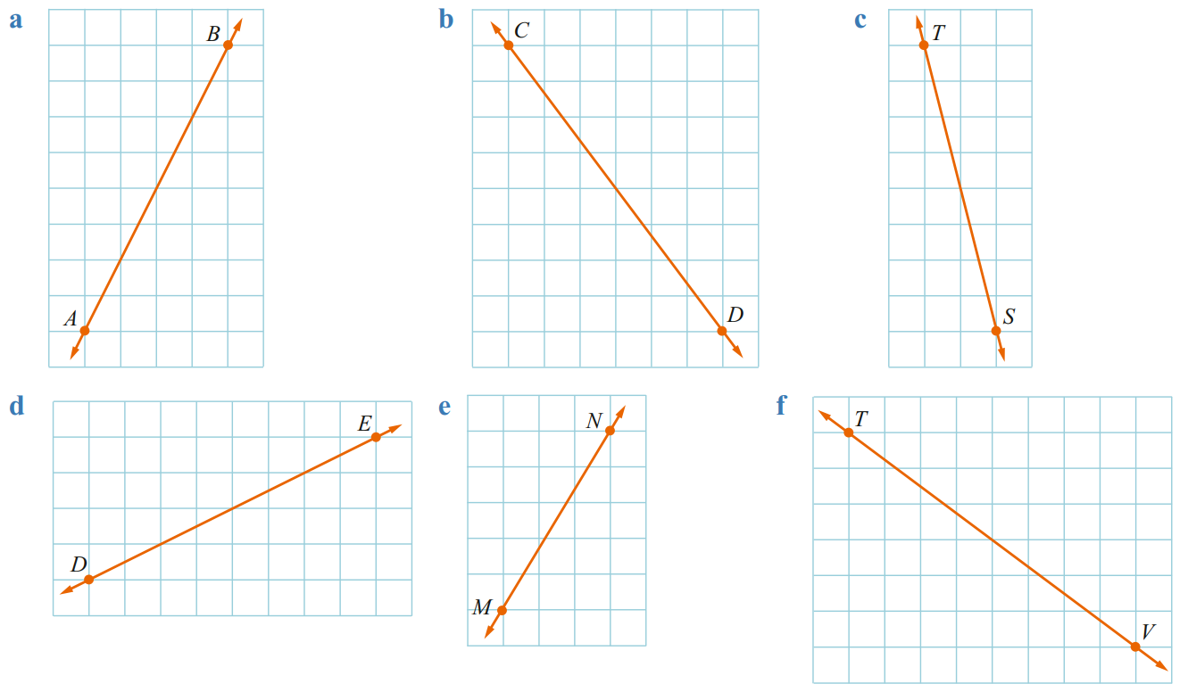  Positive | Negative  $$m=\frac{rise}{run}=$$  $$\frac{8}{4}=2$$ | Positive | Negative  $$m=$$  $$-\frac{8}{6}=-\frac{4}{3}$$ | Positive | Negative  $$m=$$  $$-\frac{8}{2}=-4$$
Positive | Negative  $m=$  $$\frac{4}{8}=\frac{1}{2}$$ | Positive | Negative  $$m=$$  $$\frac{5}{3}$$ | Positive | Negative  $$m=$$  $$-\frac{6}{8}=-\frac{3}{4}$$
- Find the gradient of these lines. Remember to check positive or negative.
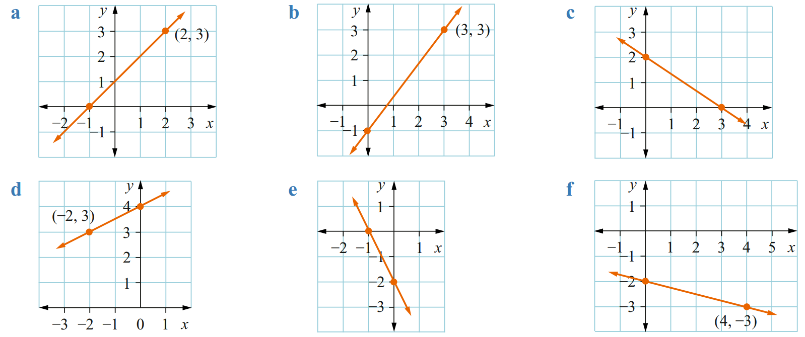  $$m=1$$ | $$m=\frac{4}{3}$$ | $$m=-\frac{2}{3}$$
$$m=\frac{1}{2}$$ | $$m=-2$$ | $$m=-\frac{1}{4}$$

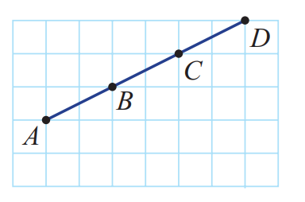
- Calculate the gradient of these line segments.
Interval | Rise | Run | Gradient
$$AB$$ | 1 | 2 | $$\frac{1}{2}$$
$$AC$$ | 2 | 4 | $$\frac{1}{2}$$
$$AD$$ | 3 | 6 | $$\frac{1}{2}$$
$$BC$$ | 1 | 2 | $$\frac{1}{2}$$
$$BD$$ | 2 | 4 | $$\frac{1}{2}$$
$$CD$$ | 1 | 2 | $$\frac{1}{2}$$

What do you notice about the gradient between points on the same line?
They are the same
Does it matter which two points you pick on a line to calculate gradient?
No

- Tom climbs a rocky slope that rises 12 m for each 6 metres across.
His friend Jonathan climbs a nearby grassy slope that rises 23 m for each 12 m across.
Which slope is steeper?
Tom: $\frac{12}{6}=2$, Johnathan: $\frac{23}{12}<2$
Tom’s slope

Gradient from Coordinates

- Review
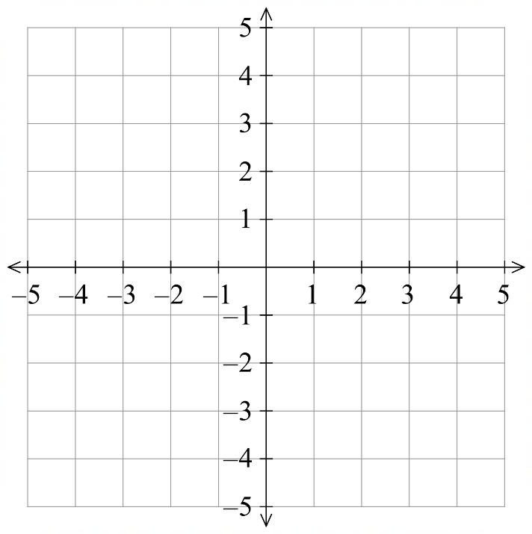
- Plot points on the Cartesian plane and join them to form an interval
- $(-4,2)$ and $\left(4,4\right)$ | - $\left(0,2\right)$ and $(2,0)$
- $(2,3)$ and $\left(5,-4\right).$ | - $\left(-4,3\right)$ and $(1,-2)$

- Gradient from Coordinates
- Plot the two coordinates on the Cartesian plane.
- Find the rise
- Find the run
- Calculate gradient $m=$ $\frac{rise}{run}$.
- Simplify the fraction, if you can.
- Example Calculate gradient from two coordinates by plotting the points
Find the gradient between $(-4,2)$ and $\left(4,4\right)$  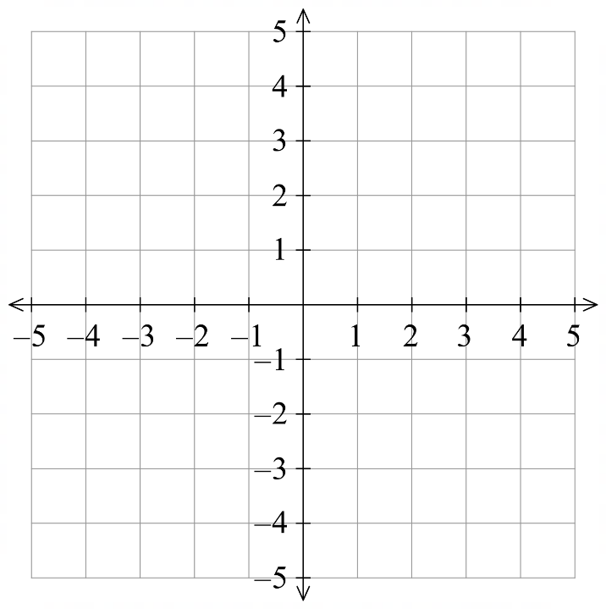  1. Rise $=$ 2  2. Run $=$ 8  3. $m=$ $\frac{Rise}{Run}$  $=$ $\frac{2}{8}$  4. $=$ $\frac{1}{4}$ | Find the gradient between $\left(0,2\right)$ and $(2,-2)$  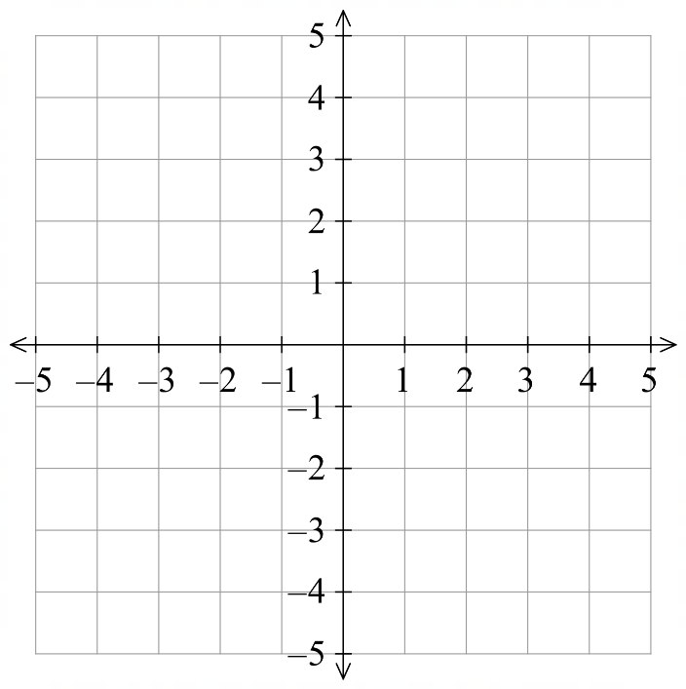  1. Rise $=$ $-4$  2. Run $=$ $2$  3. $m=$ $\frac{Rise}{Run}$  $=$ $\frac{-4}{2}$  4. $=-2$

- Guided Practice
Find the gradient of these intervals
- $(-2,4)$ and $\left(3,1\right).$  Rise $=$  Run $=$  $$m=\frac{Rise}{Run} \\ =$$  $$-\frac{3}{5}$$ | - $\left(0,5\right)$ and $(5,0)$  Rise $=$  Run $=$  $$m= \\ =$$  $$-1$$
- $(-3,2)$ and $\left(4,2\right)$  $$0$$ | - $\left(-3, -1\right)$ and $\left(1, -3\right)$  $$-\frac{1}{2}$$

Foundation
- Plot these points on the Cartesian plane and calculate the gradient of the interval.
- $A(2, 3)$and $B(3, 5)$  Rise: ………  Run: ………  $m=$ ………  2 | - $A(0,3)$ and $B(3,0)$  Rise: ………  Run: ………  $m=$ ………  –1
- $A(-1,0)$ and $B(0,-3)$  –3 | - $A(-2,5)$ and $B(0,2)$  $$-\frac{3}{2}$$
- $C(-2, 4)$ and $D(1, -2)$  –2 | - $C(3, -4)$ and $D(1, 1)$  $$-\frac{5}{2}$$

Development

- Charlotte and Naomi are arguing about a gradient of $\frac{1}{2}$
This means the line rises 1 unit for every 2 units run.


This means the line rises half a unit for every 1 unit run.

Explain why they are both correct.

Both represent the same ratio of $\frac{1}{2}$

- HSC Standard 2 Sample Question Band 4
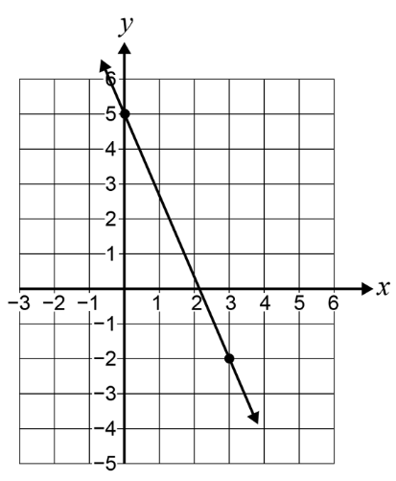
Leo drew a straight line through the points (0, 5) and (3, −2).
What is the gradient of the line?

$$m=-\frac{7}{3}$$
- 2004 HSC Standard 2 Band 3
What is the gradient of the line?
The axis scales are different. Do not count the squares.
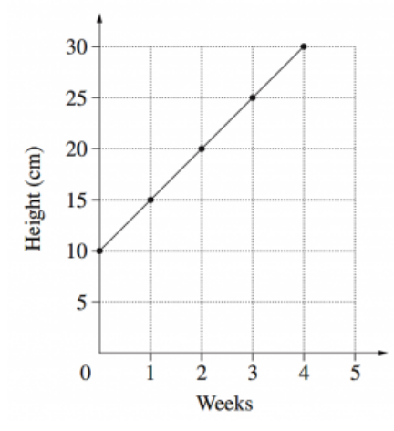

5

Mastery
- Calculate the gradient of these lines. There is no grid so you must use the coordinates.
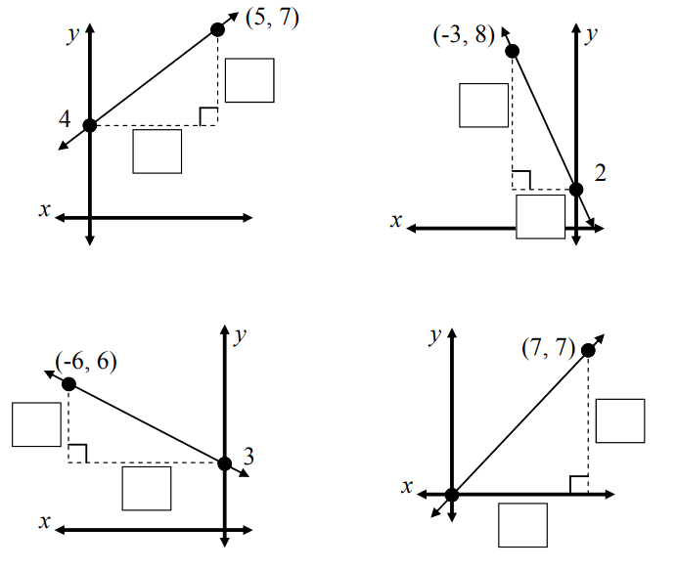  $m=$  $$\frac{3}{5}$$ | $m=$  $$-2$$ | $m=$  $$1$$
$m=$  $$-\frac{1}{2}$$ | 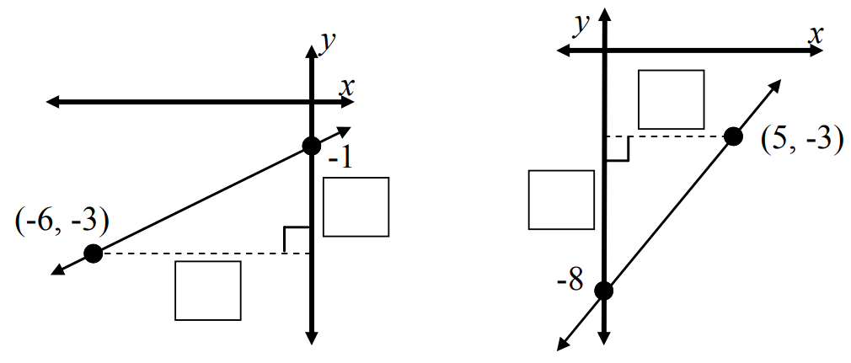  $m=$  $$\frac{1}{3}$$ | $m=$  $$1$$
- Calculate the gradient of these lines. The axis scales mean you cannot count the squares.
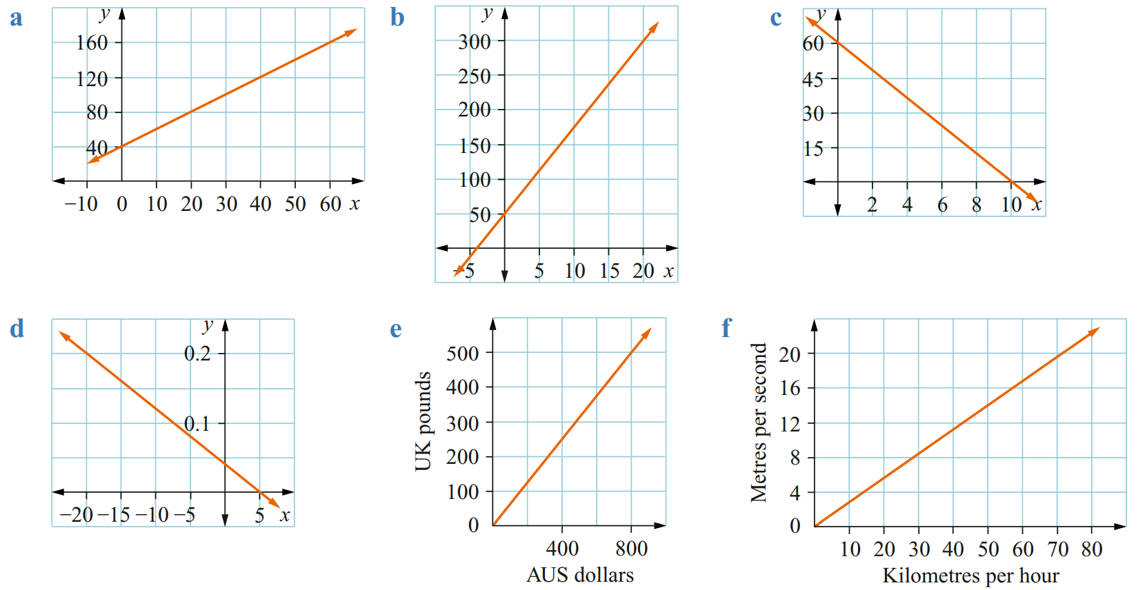  $m=$  2 | $m=$  12.5 | $m=$  –6
$m=$  –0.008 | $m=$  $$\frac{5}{8}$$ | $m=$  $$\frac{2}{7}$$
- Find the gradient of these lines.
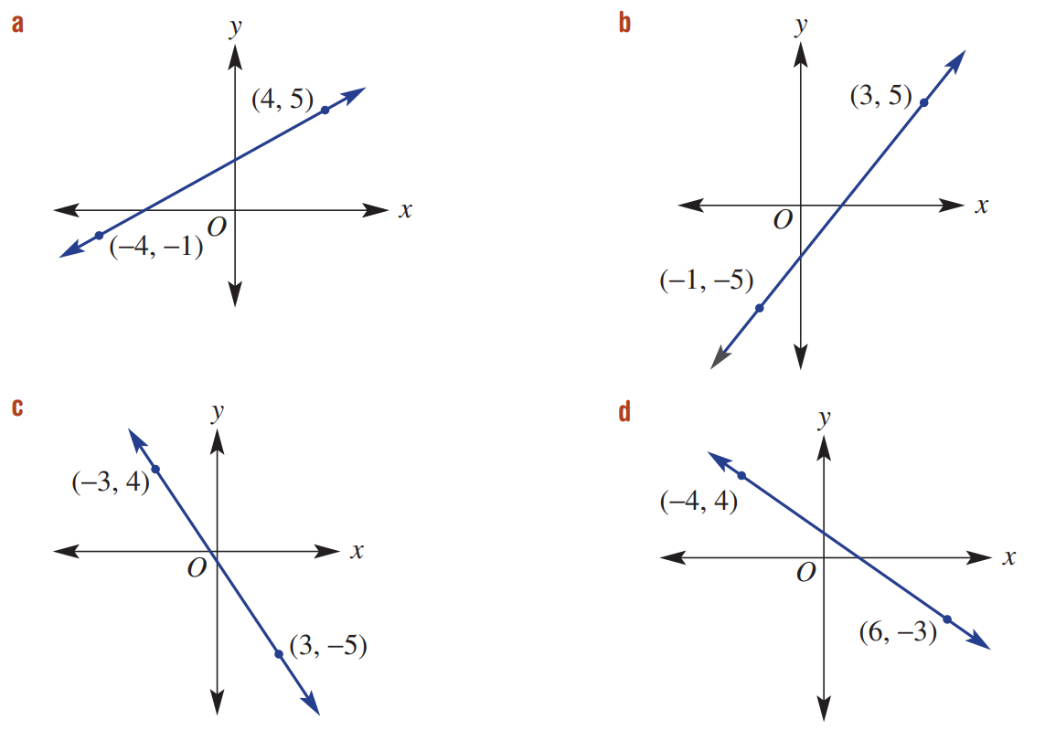  $$\frac{3}{4}$$ | $$\frac{5}{2}$$ | $$-\frac{3}{2}$$
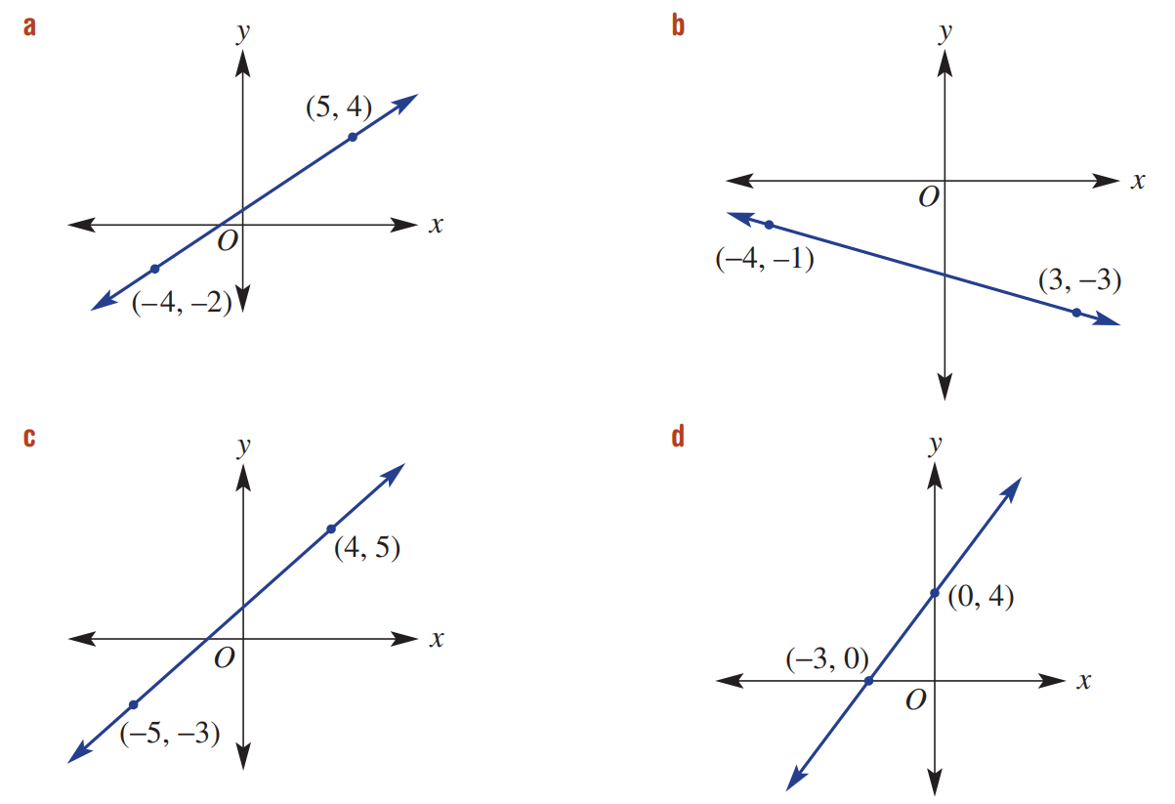  $$\frac{2}{3}$$ | $$-\frac{2}{7}$$ | $$\frac{8}{9}$$
- $(-3,1)$ and ($4,-2)$  $$-\frac{3}{7}$$ | - $(-2,-5)$ and $(1,7)$  $$4$$ | - $\left(5,-2\right)$ and $(-4,6)$  $$-\frac{8}{9}$$

Midpoint

- Review
- Identify the midpoint of two numbers
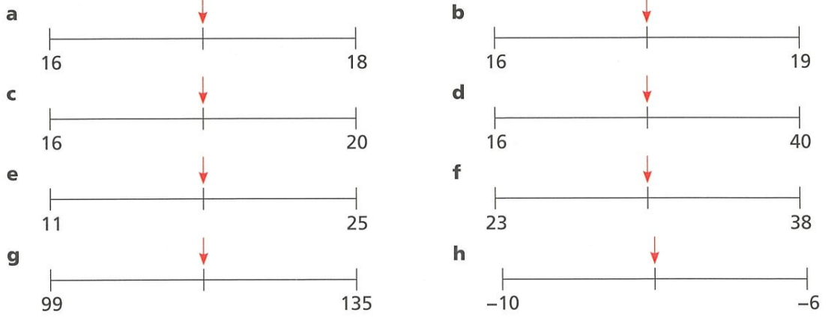

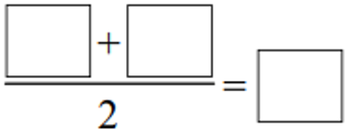

- Identify the midpoint of numbers using the mean
- 3 and 5 | - 7 and 16.5
- 4 and 6 | - 7 and 15
- 4 and 7 | - 0.7 and 1.5
- 3 and 7 | - $-7$ and $-15$
- 3 and 9 | - $-7$ and $-16$
- 3.5 and 9 | - $-6$ and $-16$
- 7 and 18 | - $-6$ and $16$
- 7 and 17 | - $6$ and $-16$

- Midpoint Formula
Midpoint is halfway between two endpoints.
- Midpoint: https://www.geogebra.org/m/uepqnx7k
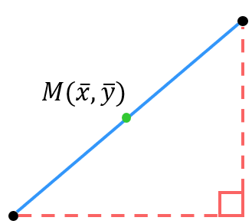
To find the midpoint, calculate the average, or mean, of the endpoints: $mean=\frac{a+b}{2}$

$$M=(Mean of x, Mean of y)$$
$=\left(\overline{x},\overline{y}\right)$

To find the midpoint of an interval:
- Find $x$ midpoint, $\overline{x}$, the mean of the $x$-coordinate endpoints.
- Find $y$ midpoint, $\overline{y}$, the mean of the $y$-coordinate endpoints.
- The midpoint is $M=\left(\overline{x},\overline{y}\right)$

- Example Calculate midpoint of an interval
Find the midpoint of $\left(0,4\right)$ and $(3,1)$  $$1. \overline{x}=\frac{0+3}{2}$$  $=1.5$  $$2. \overline{y}=\frac{4+1}{2}$$  $$=2.5$$  $$3. M=(1.5 , 2.5)$$ | Find the midpoint of $\left(-3,1\right)$ and $(2, -5)$  $$1. \overline{x}=\frac{-3+2}{2}$$  $=-0.5$  $$2. \overline{y}=\frac{1+\left(-5\right)}{2}$$  $$=-2$$  $$3. M=(3 , 2.5)$$

- Guided Practice
Find the midpoint of:
- $(5,-2)$ and $(1,4)$  $\overline{x}=$ ………  $\overline{y}=$ ………  $M=$ ( , )  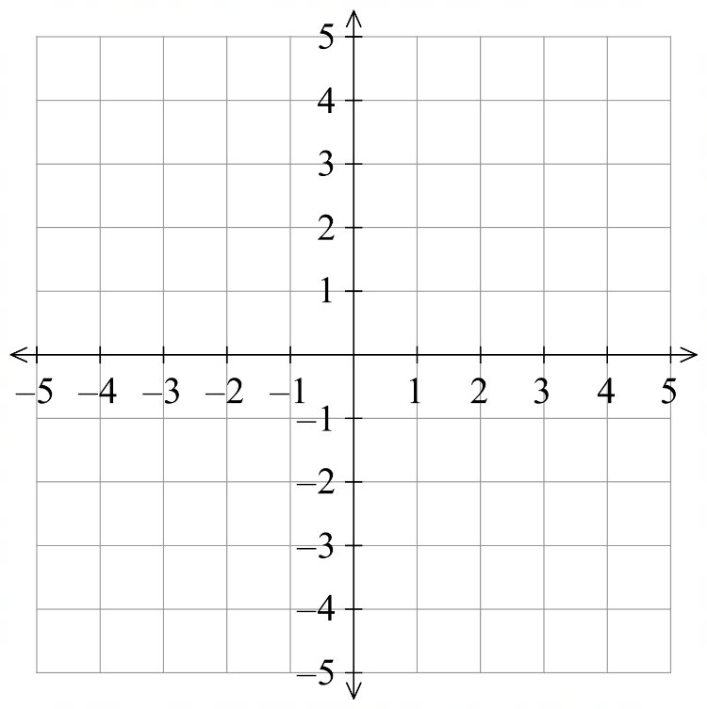  $$\left(3,1\right)$$ | - $\left(-2,-5\right)$ and $(3,-1)$  $\overline{x}=$ ………  $\overline{y}=$ ………  $M=$ ( , )  $$\left(0.5,-3\right)$$

- Key Ideas
- The midpoint is the ………………… of the $x$ and $y$ coordinates.

Foundation
- Sketch the line interval and calculate the midpoint.
- $(1, 2)$ and $(1, 4)$  $\overline{x}=$  $\overline{y}=$  $M=( , )$  (1, 3) | - $(-2, 1)$ and $(-2, 5)$  $\overline{x}=$  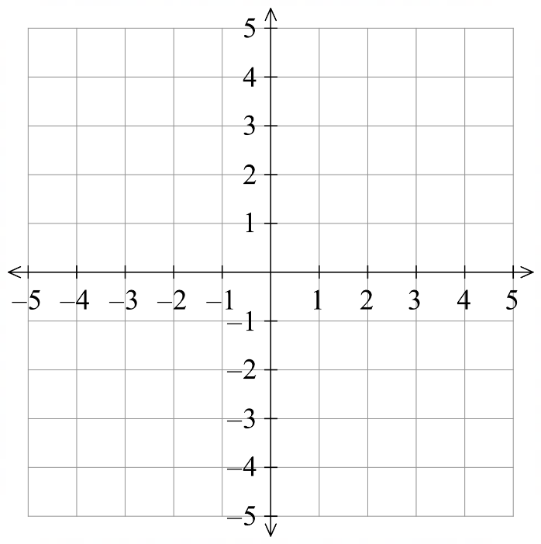  $\overline{y}=$  $M=( , )$  (−2, 3)
- $(0, 0)$ and $(3, 0)$  $\overline{x}=$  $\overline{y}=$  $M=( , )$  (1.5, 0) | - $(5, 1)$ and $(3, 1)$  $\overline{x}=$  $\overline{y}=$  $M=( , )$  (4, 1)

- $(5, 2)$ and $(1, 4)$  $\overline{x}=$  $\overline{y}=$  $M=( , )$  (3, 3) | - $(2, 0)$ and $(0, 8)$  $\overline{x}=$  $\overline{y}=$  $M=( , )$  (1, 4)
- $(2, -1)$ and $(-1, 3)$  (0.5, 1) | - $(-4,-4)$ and $(-1, 1)$  (−2.5, −1.5)

Development
- Calculate the midpoint of the line segment.
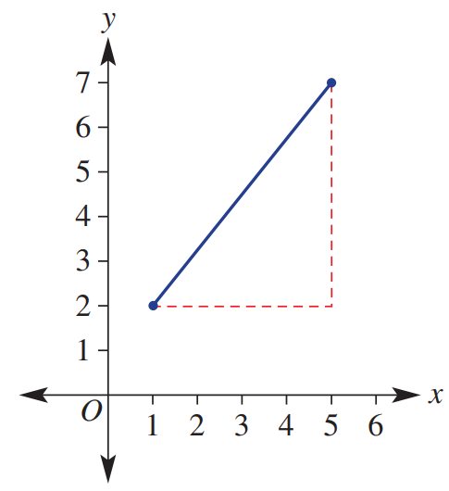  $$(3, 4.5)$$ | 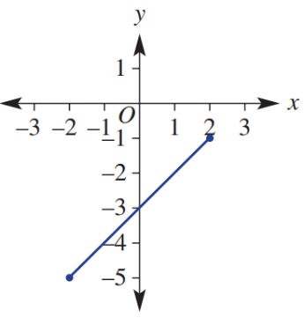  $$(0, -3)$$

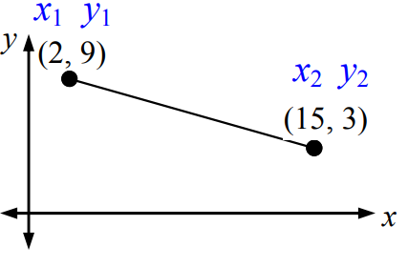
- Find the midpoint of these line segments.
$$(8.5, 6)$$ | 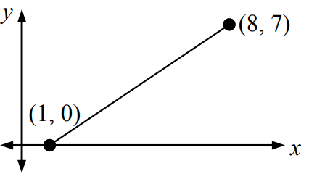  $$\left(4.5, 3.5\right)$$ | 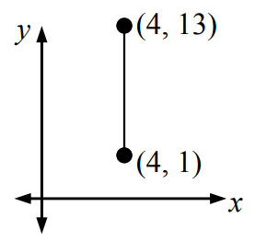  $$\left(4, 7\right)$$
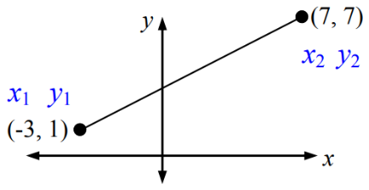  $$(2, 4)$$ | 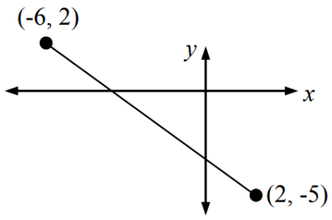  $$\left(-2, -1.5\right)$$ | 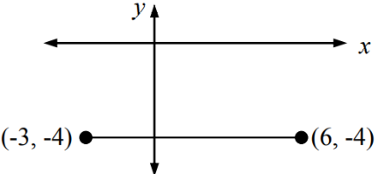  $$(1.5, -4)$$
- $(-3,1)$ and ($4,-2)$  $$(0.5, -0.5)$$ | - $(-2,-5)$ and $(1,7)$  $$\left(-0.5, 1\right)$$ | - $\left(5,-2\right)$ and $(-4,6)$  $$\left(0.5, 2\right)$$

Distance

- Review
- Calculate square roots and round to 2 d.p.
- $\sqrt{43}$ | - $\sqrt{75}$ | - $\sqrt{66}$ | - $\sqrt{59}$ | - $\sqrt{28}$

- Calculate squares
- $8^{2}+4^{2}$ | - $5^{2}+7^{2}$ | - $6^{2}+3^{2}$ | - $2^{2}+8^{2}$ | - $4^{2}+{10}^{2}$

- Find the length of the hypotenuse using Pythagoras’ theorem, round to 2 d.p.
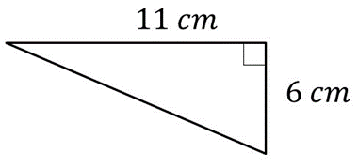 | 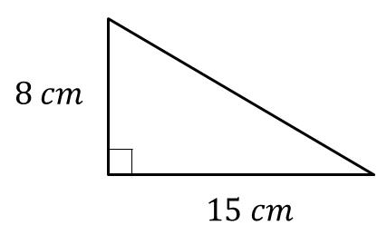 | 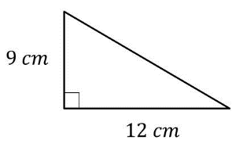

- Distance Formula
- Distance: https://www.geogebra.org/m/t94gke48
Pythagoras' theorem calculates the distance, or length, between two points.
$$d^{2}={rise}^{2}+{run}^{2} \\ d=\sqrt{{rise}^{2}+{run}^{2}}$$

- Example Calculate length of an interval
Find the length between $\left(0,-1\right)$ and $(3,4)$  $$d=\sqrt{5^{2}+3^{2}}=\sqrt{34}$$  $≈5.83$ units | Find the length between $\left(-3,1\right)$ and $(2, -5)$  $$d=\sqrt{{\left(-6\right)}^{2}+5^{2}}=\sqrt{61}$$  $≈7.81$ units

- Guided Practice
Find the length, to 2 d.p. where necessary, between:
- $(1,1)$ and $(5,4)$  5 | - $\left(-4,-3\right)$ and $(2,1)$  $$7.21$$

- Key Ideas
- The length between two coordinates is calculated using ………………… theorem.

Foundation
- Calculate the distance of these intervals. Check your answer by measuring with a ruler.
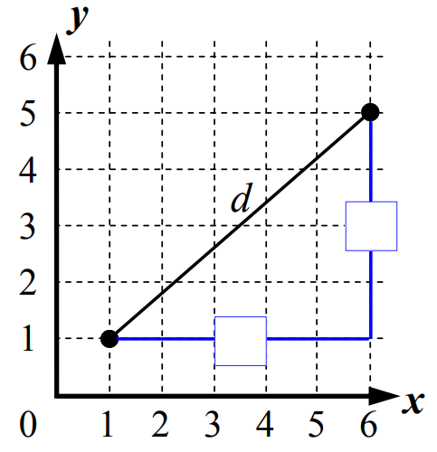  Rise ………  Run ………  $$d=\sqrt{{\left( \right)}^{2}+{\left( \right)}^{2}}$$  $=$  6.40 | 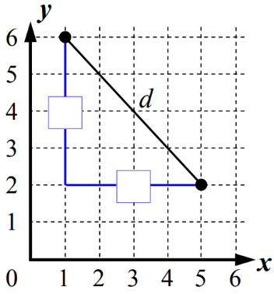  Rise = ………  Run = ………  $$d=\sqrt{{\left( \right)}^{2}+{\left( \right)}^{2}}$$  $=$  5.66

- Calculate the distance of these intervals to 2 d.p. You won’t be able to use a ruler.
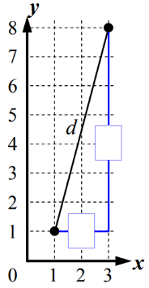  7.28 | 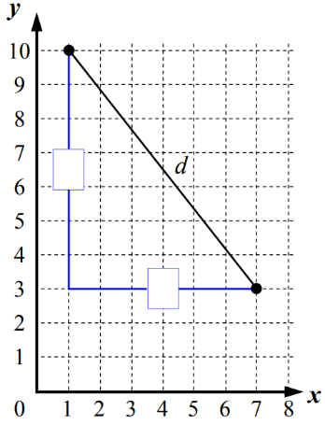  9.22

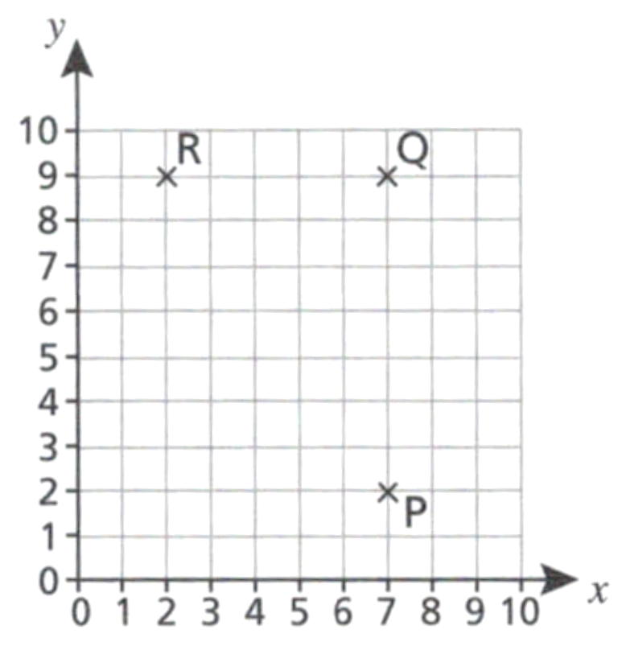
  - Write the length of PQ
7 units
  - Write the length of QR
5 units
  - Use Pythagoras' theorem to show that
PR = 8.6 units to 1 decimal place.

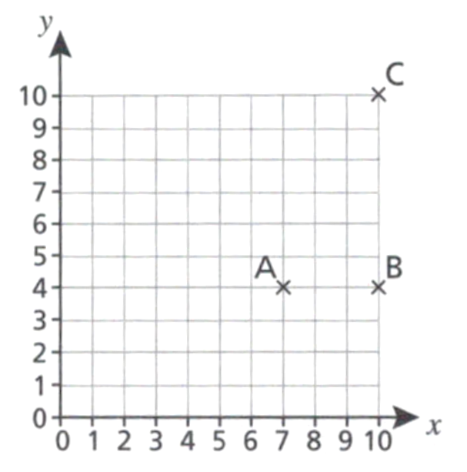
  - Write the length of AB
3 units
  - Write the length of BC

6 units
  - Use Pythagoras' theorem to work out the length of AC.
Give your answer to 1 decimal place.

6.7 units
- Calculate the distance of these intervals. Answer to 1 d.p.
- $(4,5)$ and $(1, -3$)  8.5 | - $(-3,4)$ and $(-1,-2)$  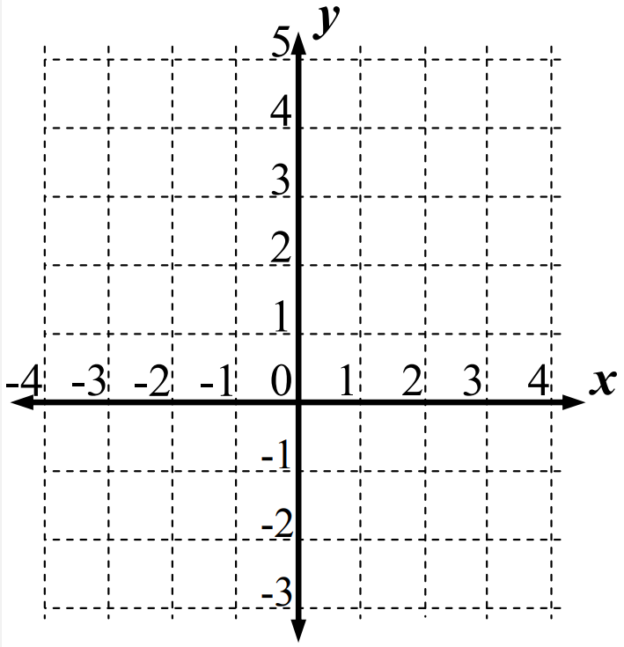  6.3
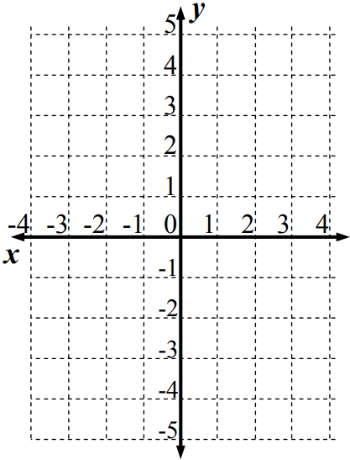  - $(-4,4)$ and $(2, 5$)  6.1 | - $(-4,2)$ and $(1,-5)$  8.6

Development
- Plot these intervals on the Cartesian plane and calculate the distance to 1 d.p.
- $(0, 1)$ and $(4, 7)$  7.2 | - $(-2, -1)$ and $(4, -2)$  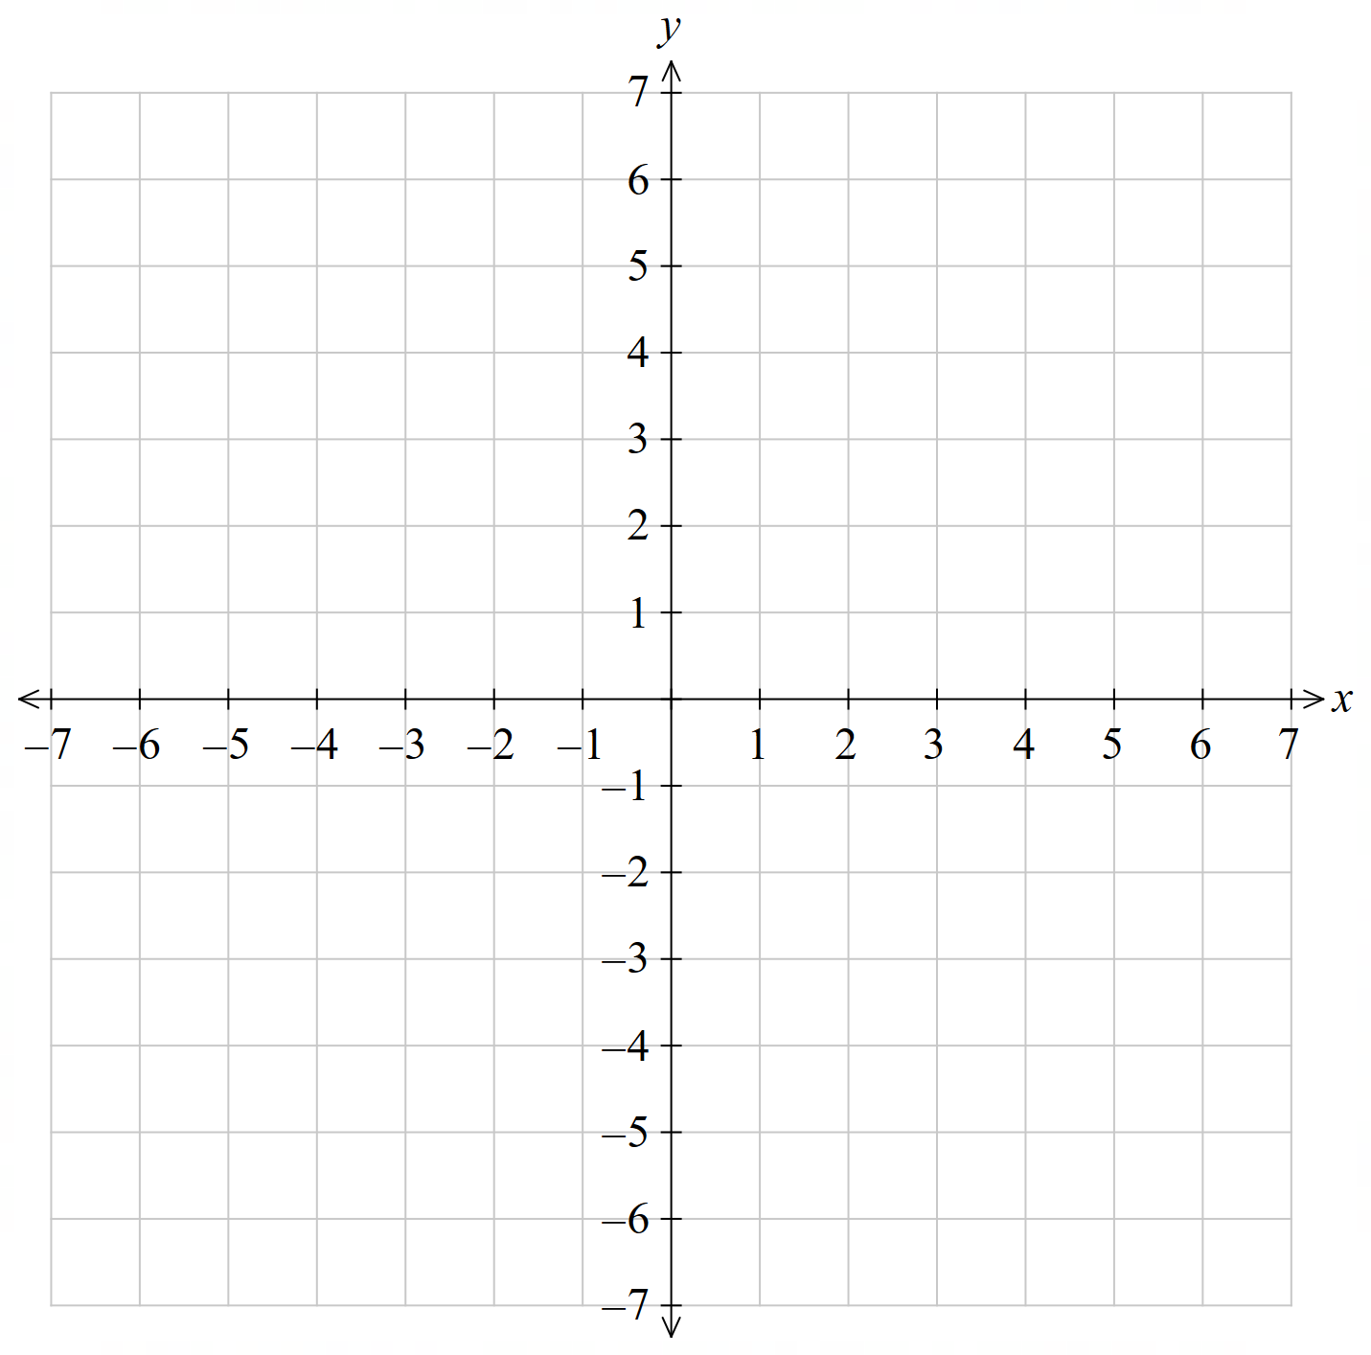  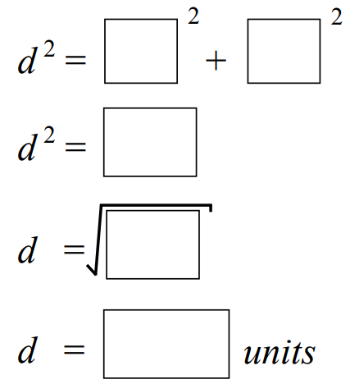  6.1
- $(-5, 3)$ and $(6, 2)$  11.0 | - $(-7, 0)$ and $(5, -4)$  12.6
- Calculate the distance between these two points to 1 d.p.
10.6 | 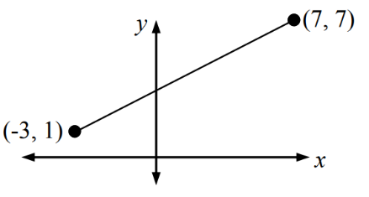  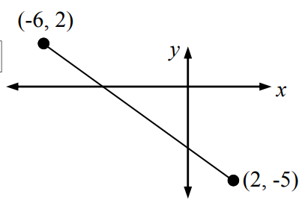  11.7
- Find the midpoint, gradient, and length of these line segments. Give lengths to 1 d.p.
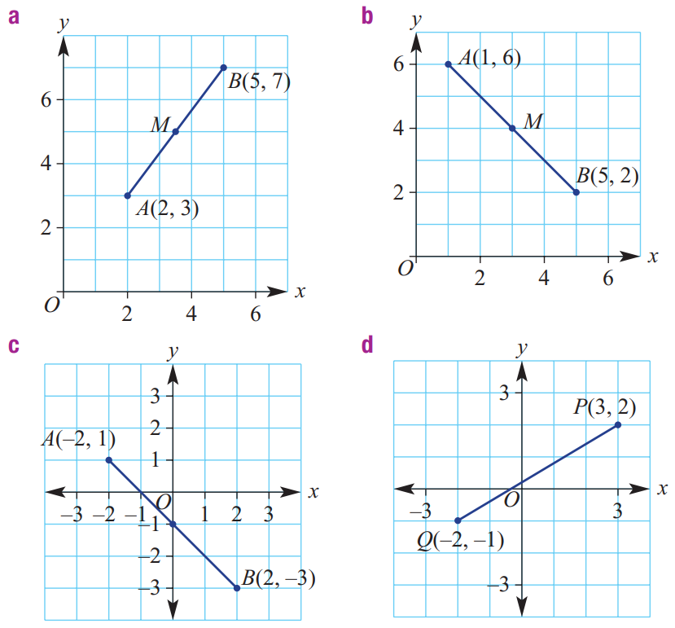  $$Midpoint: \left(3.5,5\right), Gradient:\frac{4}{3}, Length: 5.0$$ | $$Midpoint: (3,4), Gradient: -1, Length: 5.7$$
$$Midpoint: (0,-1), Gradient: -1, Length: 5.7$$ | $$Midpoint: \left(\frac{1}{2},\frac{1}{2}\right), Gradient:\frac{3}{5}, Length: 5.8$$

- A block of land is shown on this map. Each unit distance represents 100 metres in real life. Calculate the perimeter of the block.
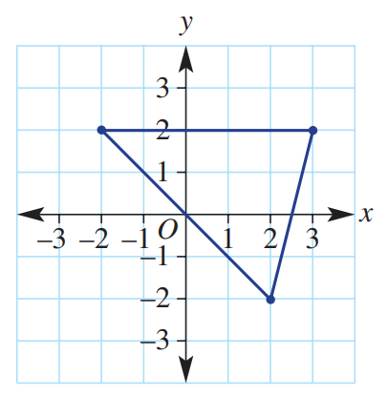

1478 m

